**Instruction Production Specifications, Final Prototype, and Assessment**

**Part 1: Product Specifications**

|  |  |
| --- | --- |
| **Heading 1**  Font: Calibri Light (Heading)  Font Size 16pt  Font Color: Blue  Font Weight Normal  Alignment: Center  **Heading 2**  Font: Calibri (Body)  Font Size: 14pt  Font Color: Green  Font Weight: Normal  Alignment: Left  **Heading 3**  Font: Calibri (Body)  Font Size: 12pt  Font Color: Black  Font Weight: Bold  Alignment: Left  **Body Text**  Font: Calibri (Body)  Font Size: 12pt  Font Color: Black  Font Weight: Normal  Text Alignment: Left  Paragraph Alignment: Left | **Emphasis**  Font: Calibri (Body)  Font Size: 12pt  Font Color: Black  Font Weight: Bold  **Note Text:**  Font: Calibri (Body)  Font Size: 12pt  Font Color: Black  Font Style: Italic  Alignment: Left  **Web Links:**  Font: Calibri (Body)  Font Size: 12pt  Font Color: Blue, underlined  **Page Numbers:**  Font: Calibri (Body)  Font Size: 12pt  Font Color: Black  Alignment: Top Right  **Line Spacing:** Single-spaced  **Paragraph Spacing:** Double-spaced  **Justification:** Left  **Page Breaks:** Automatic  **Text Wrap:** Images in line with text |

|  |
| --- |
| **Page Layout Design Grid:** The page diagram and specifications provide an example for developing full-sized instruction materials for the lesson.    **Page Margins:** Page margins will have a 1” margin for all dimensions, Top, Bottom, Left and Right. Page numbers will be in upper, right corner.  **Main Headings:** Main headings will be blue, Calibri font size 16, Normal.  **Sub Headings:** Sub headings will be green, Calibri font size 14, Green  **Body Text** is Calibri font size 12, black, and normal weight. Note text is italicized, emphasis text is bold.  **Graphics:** Graphics will be left aligned and wrapped in line with text.  **Links:** All links will be blue and underlined. |

**Part 2: Final Product and Assessment**

**ProQuest Central Database Training**



Wayne State University Library

Instruction

Table of Contents

Introduction 5

Lesson Objectives 6

Body and Practice Activity 7

Accessing and Navigating the ProQuest Central Database 7

Practice Activity 12

Practice Activity Results 13

The Functions of the Advanced Search Tool 14

**Boolean operators** 14

**Peer reviewed** 16

**Full text** 16

**Cite** 16

**Email** 17

Review and Summary 18

Assessment 19

Part 1 19

Part 2 21

Answer Key Part 1 23

Answer Key Part 2 24

Reference 26

# Introduction

**Where do you go to gather information?**

We live in a time where there is a huge swath of information available to us. If we’re honest with ourselves, it can feel like an overwhelming amount. In a landscape such as ours, how do we wisely navigate the information that is available?

That question is a key one throughout your time in college as well. Conducting research is a necessary part of a student’s education throughout a whole host of different disciplines. It can, again, feel overwhelming to conduct research for your various assignments. The great news is that there are tools to help you conduct and refine your searches for sources. They are called databases.

The Wayne State library website has a whole host of specific databases ready to be used at your disposal. It is important to be able to navigate around a database and use the tools located within them, because it will make your search process less of a headache and make your time spent researching much more efficient. The database that we will be based out of today will be the ProQuest Central database, as you can see below:

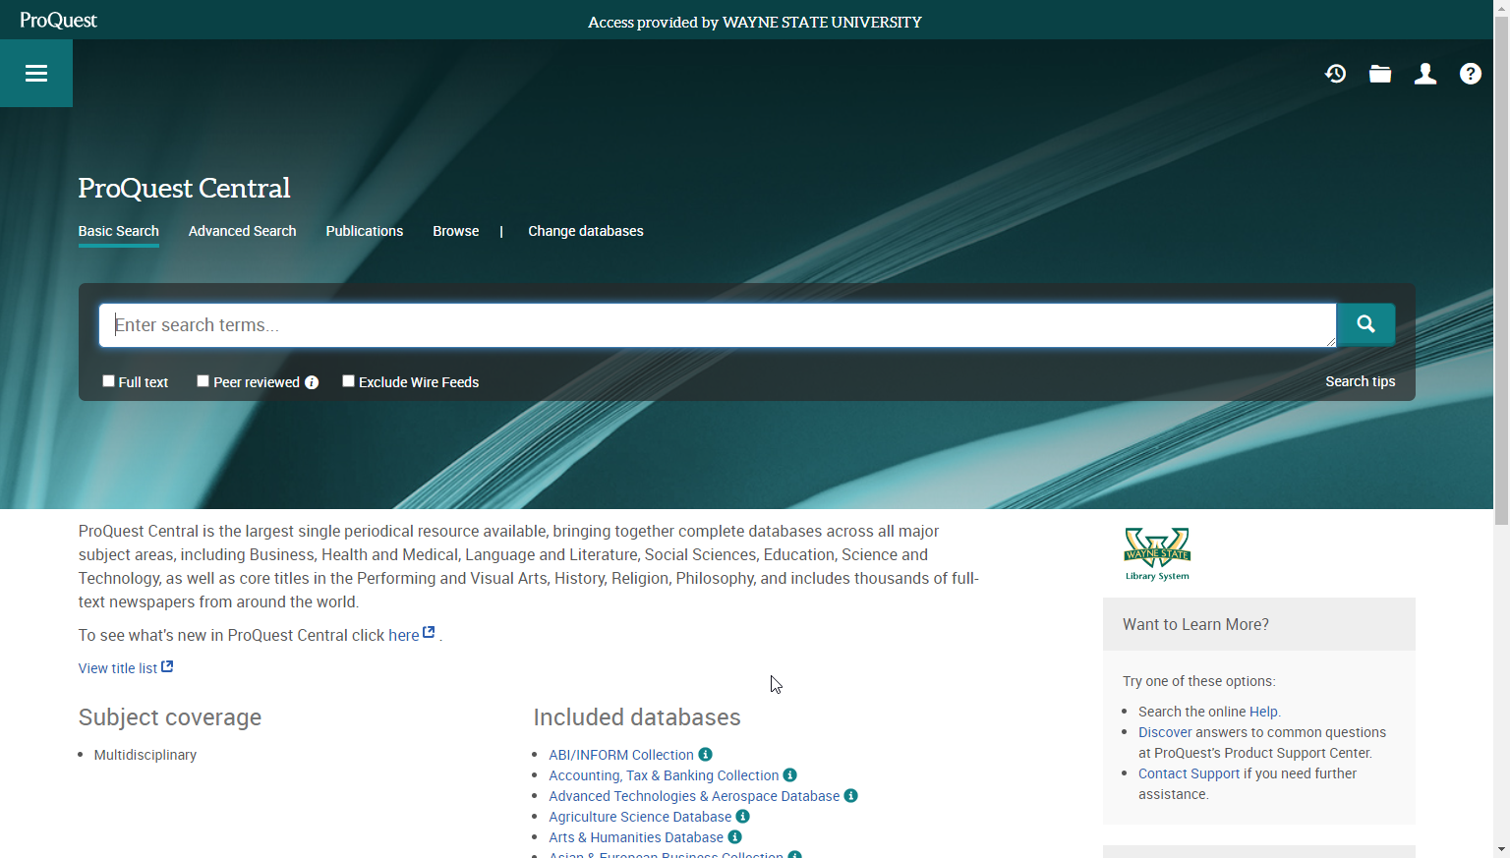

# Lesson Objectives

After completing this lesson, you will be able to:

1. Locate the Wayne State University library homepage.
2. Access and sign into the ProQuest Central database.
3. Navigate the ProQuest Central database and locate several of the basic tools available on the homepage.
4. Understand and differentiate between the AND, OR, and NOT Boolean search operators by matching each Boolean operator to a description of what each operator accomplishes in your search.
5. Match the different functions located within the Advanced Search tool to a corresponding description of what each feature will provide you.
6. List the order, or the proper steps, in which to use each function located in the Advanced Search tool to conduct the best possible searches.

This lesson will focus on two main areas: First, accessing the ProQuest Central database and being able to navigate the database. Second, using various functions located in the Advanced Search tool and understanding how they relate to each other.

# Body and Practice Activity

## Accessing and Navigating the ProQuest Central Database

To start, before we even get into navigating the ProQuest Central database, it’s important right off the bat to discover how to get to the database in the first place. That’s where the Wayne State University library website is going to be a great help for us.

Here’s the layout of the Wayne State University library website homepage, as you can see below:

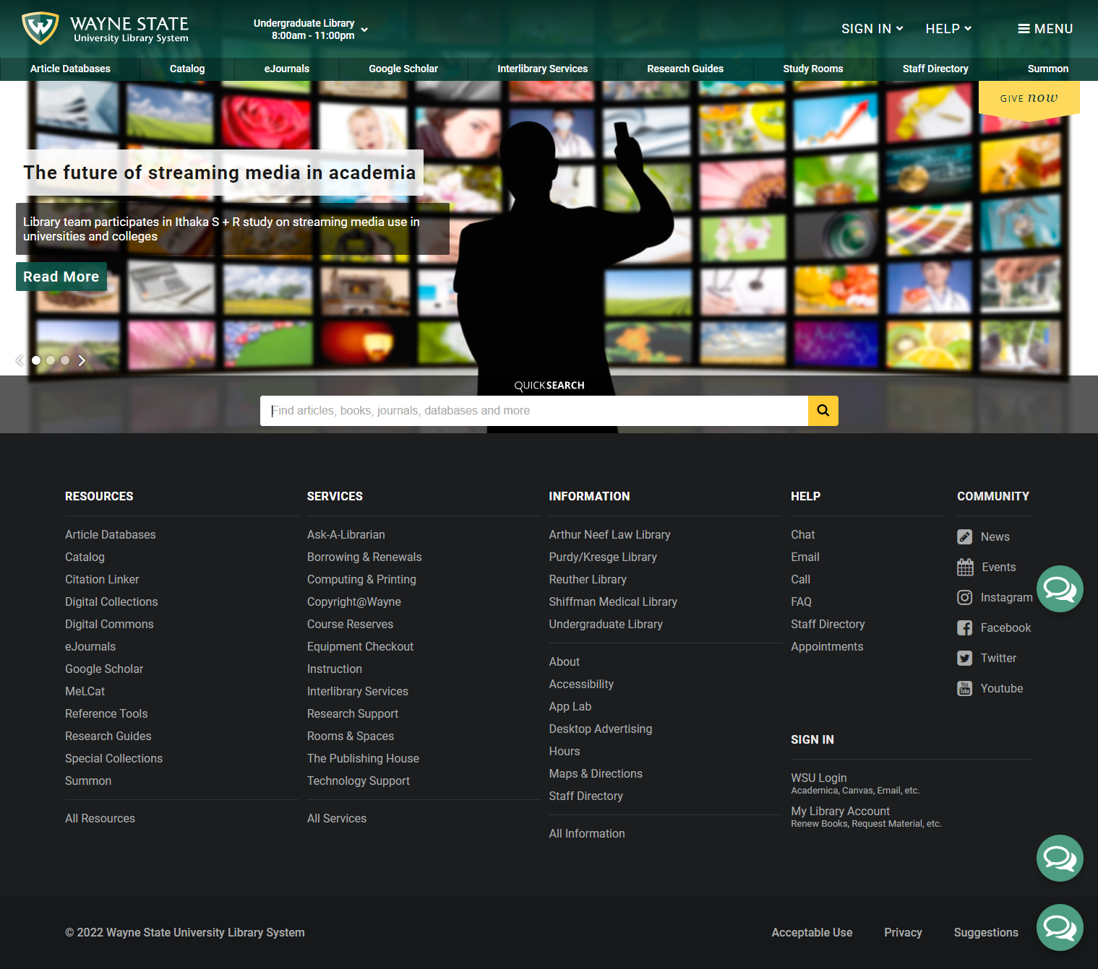

As you can see, there’s a lot to navigate right in that homepage. A couple highlights:



As shown above, the URL for accessing the Wayne State University library is <https://library.wayne.edu>



As shown above, this is where you find the Article Databases tab on the Wayne State University library homepage.

You will then need to find the ProQuest Central database. The most efficient way to do so, saving you some time spent scrolling, is simply to type in “ProQuest Central” into the search bar near the top of the page, as shown below:

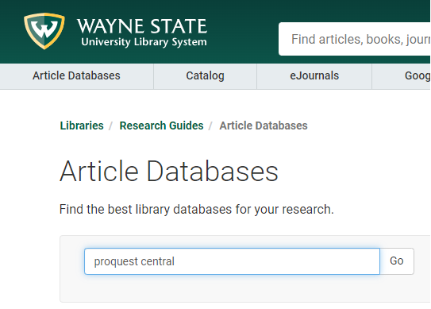

Once you select “Go”, the ProQuest Central database will come up, you will click on it and you will be prompted to enter your Wayne State AccessID and password to sign into it, as shown below:

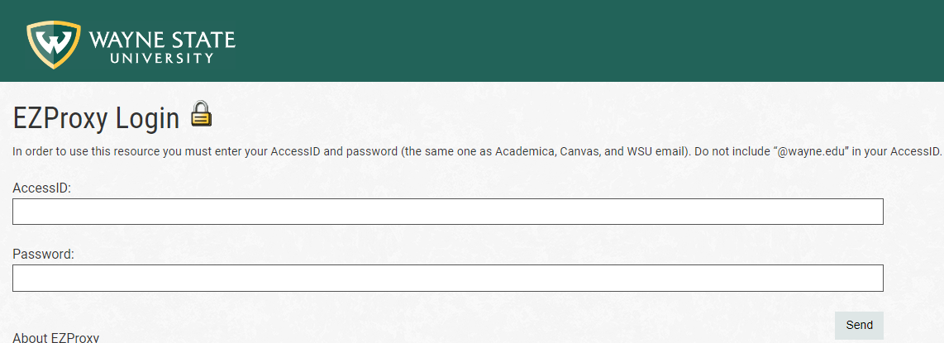

Once you arrive at the ProQuest Central database there are several important things to take stock of right away, as you will see below:

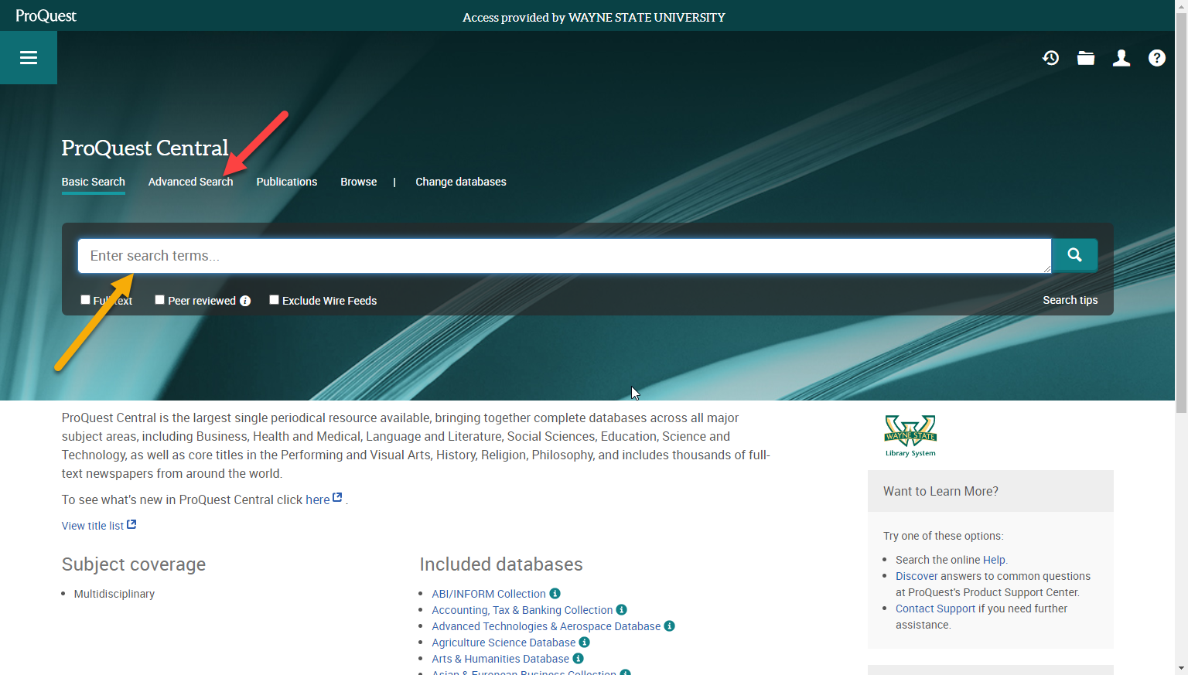

The yellow arrow points to the Basic Search bar, which you can feel free to use for your searches. But importantly, the red arrow points to the Advanced Search tool. It’s that Advanced Search tool that will be worth considering further, because being able to use the functions located within will help refine and maximize your searches.

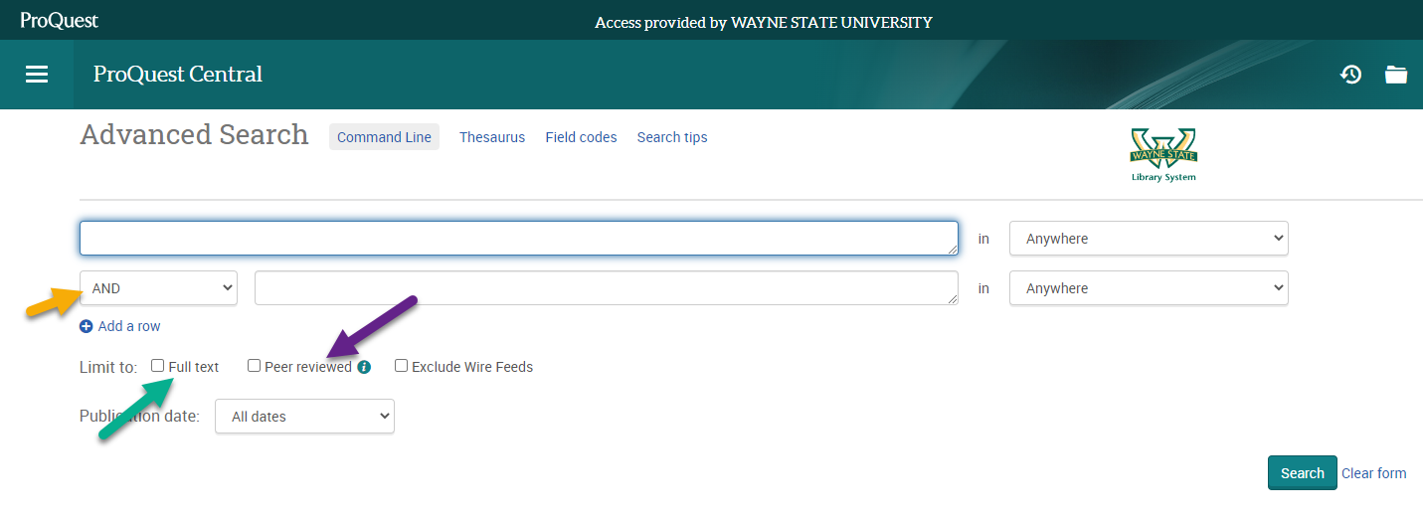

Above, the yellow arrow points you to the Boolean operator. The specific one highlighted here is the AND Boolean operator, but there are two more that you can use as well, those being the OR, and NOT operators (more on those later).

Also note the two other arrows shown above. The green arrow points to the Full text function, and the purple arrow points to the Peer reviewed function.

There are other very helpful functions to continue highlighting within the Advanced Search tool:

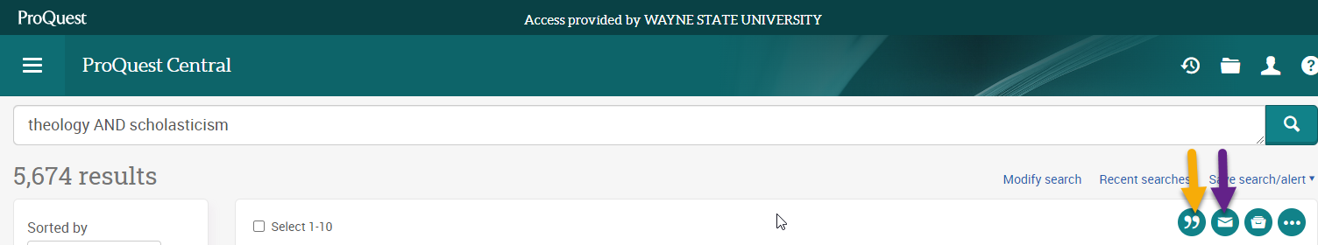

As you can see, I conducted a search here. But note the two arrows. The yellow arrow points to the Cite feature, and the purple points to the Email feature.

At this point we haven’t discussed what it is that any of these functions “do” or “accomplish” for your searches or how they help your research process, and that’s ok. It’s important to note right at the start simply what the names of these functions are, and where to find them as you navigate within the ProQuest Central database.

It’s at this point that we will take a bit of a break to put what you’ve learned so far into action with a practice activity.

## Practice Activity

Try to list the seven different functions we’ve looked at within the Advanced Search tool.

1. ________________________________________
2. ________________________________________
3. ________________________________________
4. ________________________________________
5. ________________________________________
6. ________________________________________
7. ________________________________________

## Practice Activity Results

**Here are the correct answers!** *How many of them did you remember? Which did you forget?*

1. AND operator
2. OR operator
3. NOT operator
4. Peer reviewed
5. Full text
6. Cite
7. Email

## The Functions of the Advanced Search Tool

So far, we’ve focused on how to navigate the ProQuest Central database, what the functions within the Advanced Search tool are named, and where to locate them within the Advanced Search tool itself. With that foundation in place, let’s focus now on what each function provides you both for your search purposes and for your research.

### **Boolean operators**

Boolean operators have their own search logic, which can help you further focus in in your research. We’ve already established the three different operators in question, the AND, OR, and NOT operator. But what is it that they exactly “do” per se?

In an earlier search in this lesson, you saw that I searched for “theology” AND “scholasticism.” That was me using the AND operator. The AND operator is a limiting operator, within the context of that search it will find all sources that have both the word “theology” and the word “scholasticism.”

What if we take that same search and apply it to the NOT operator? The NOT operator is also a limiting operator but in a different way. It would be a limiting operator that would find all sources that have the word “theology” but doesn’t have the word “scholasticism.”

And finally, the OR operator. The OR operator is an expanding operator. If we take my search for our example again, it would be an expanding operator that will find all sources that have the word “theology” and all sources that have the word “scholasticism.”

Let’s see what looks like when you conduct that search, notice the amount of results comparative to each other when you use each operator:

* **AND operator**

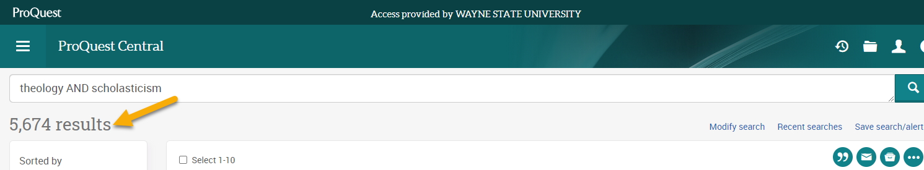

* **OR operator**

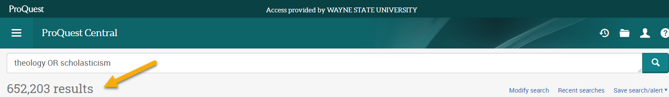

* **NOT operator**

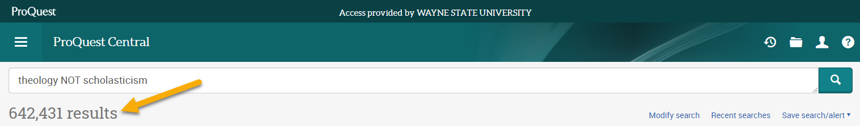

### **Peer reviewed**

There are also other helpful functions within the Advanced Search tool to help you further trim down your sources. One of the most helpful is the “Peer reviewed” function. What it means that a source has been peer reviewed is that the specific source has gone through a quality control process that was undertaken by their peers. This is a safeguard to help ensure that a published work is valid, original, and of high quality. I would strongly recommend using this function for most of your searches.

### **Full text**

This is another function I would strongly recommend using within the Advanced Search tool. When a source is marked “Full text” that means that you will have complete access to that specific source. It can be very frustrating to find a source for your research but then find out that you only have partial access to the contents. Negate that possibility and make life easier for yourself by using this function!

### **Cite**

This function within the Advanced Search tool really comes in handy for when you find a source but need some help in formatting it for a reference page, or something similar.

### **Email**

Perhaps one of the most useful functions for possible further research down the line, is the ability to email articles to yourself, allowing you to read the contents later. Once you look to use this function, it will have you fill out a form with your information, once that’s submitted you will get an email containing the contents of the specific source. The form is shown below:

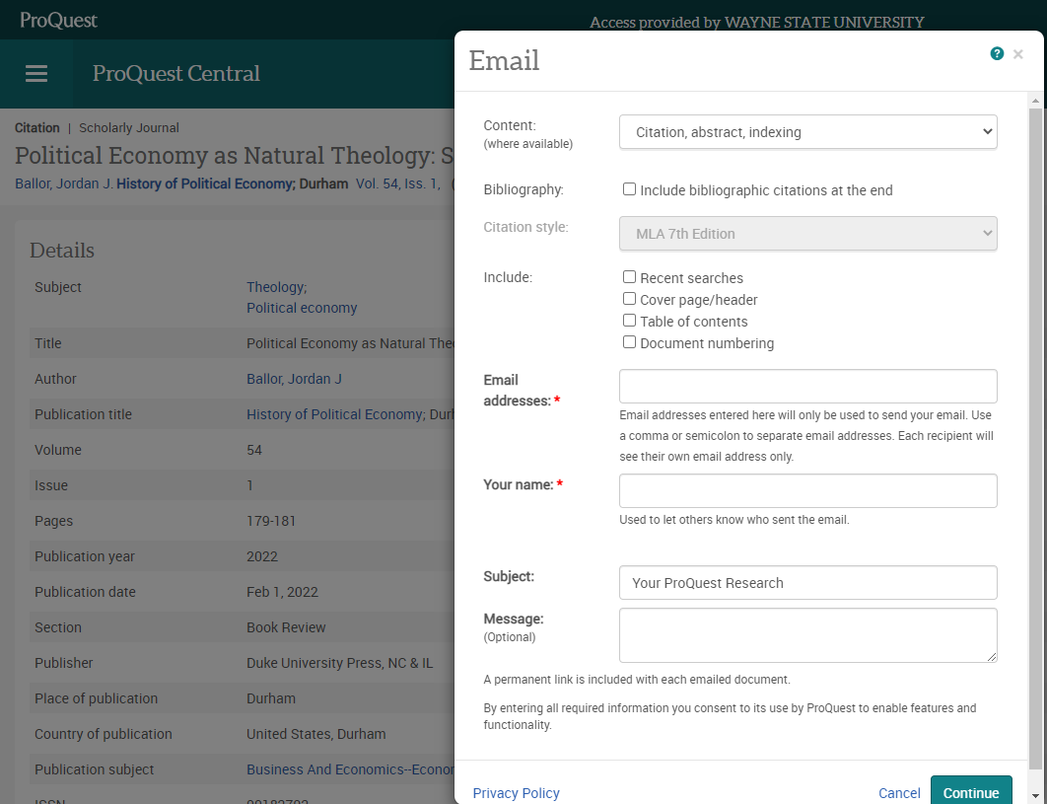

# Review and Summary

Databases are great tools that are available for you when it comes to conducting and refining your searches for sources. We’ve looked at a particular database within the Wayne State University library website, the ProQuest Central database. We’ve looked at how to access the database, and how to navigate within it. We’ve also looked at a variety of functions within the Advanced Search tool itself, and how using those can maximize your research process.

It's important to note that the functions that we’ve looked at within the Advanced Search tool all build on each other.

You would first want to search with a specific Boolean operator, that will help you narrow in on your sources. Further trim down that list by using the “Peer reviewed function” to ensure you get high quality material. Then use the “Full text” function to ensure that you will have complete access to all the sources. You can use the “Cite” function for any formatting questions you may have. The “Email” function is great for any other sources that you deem interesting.

Feel free to review anything that we’ve just covered on the ProQuest Central database before taking the assessment that follows!

# Assessment

**Directions:** This assessment measures your ability to both access the ProQuest Central database and use the tools therein. You must perform the test questions without any outside help or resources. There are two parts to the assessment. Part one will measure your recall of accessing and navigating the ProQuest Central database. Part two will check your recognition of the different Advanced Search tools within the ProQuest Central database and will also check your recall of how to use those tools in combination with each other. Please go through the assessment in order of how it’s presented.

## Part 1

**Recall the website location, user login information, and the search features.**

1. Check the correct web address (URL) of the Wayne State University library homepage.

____ <https://wayne.library.edu>

____ <https://library.wayne.edu>

____ <https://waynelibrary.edu>

1. Write your assigned Wayne State AccessID and password into the blanks provided.

1. Circle the Basic Search bar and put a checkmark on the location of the Advanced Search tool.

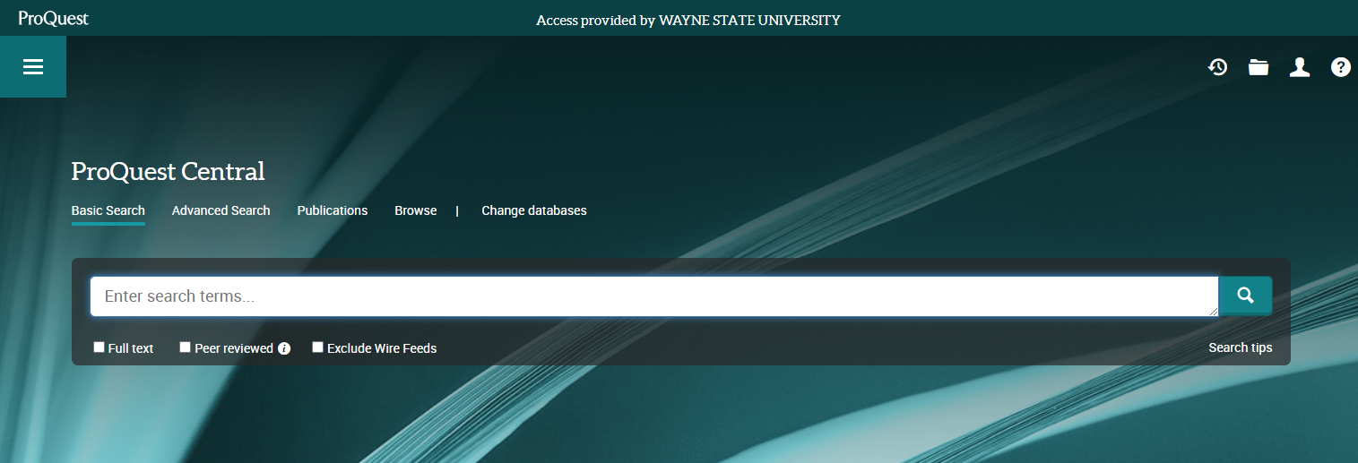

## Part 2

**Recognize the Advanced Search tools within the ProQuest Central database, recall how to use those tools in combination with each other.**

1. Match each Boolean operator to the description of what each operator accomplishes in the search.

____ AND operator

____ OR operator

____ NOT operator

Descriptions

1. A limiting operator that will find all sources that have the word “theology” but doesn’t have the word “scholasticism.”
2. A limiting operator that will find all sources that have both the word “theology” and the word “scholasticism.”
3. An expanding operator that will find all sources that have the word “theology” and all sources that have the word “scholasticism.”
4. Match each Advanced Search function to the description of what each feature provides.

____ Peer reviewed

____ Full text

____ Cite

____ Email

Descriptions

1. Will use this tool to help format your references during the research process.
2. Using this tool will give you sources that have gone through a quality control process from their peers, to help ensure that the published work is valid, original, and of high quality.
3. Filling out this tool will allow you to send the source to your own personal message inbox.
4. Using this tool will give you sources that you will have complete access to.
5. List the order to use each function located in the Advanced Search tool, as listed below, in the correct steps to conduct the best possible searched and get the best information.

____ Cite

____ Full text

____ Peer reviewed

____ Email

____ Boolean operator

## Answer Key Part 1

1. Check the correct web address (URL) of the Wayne State University library homepage.

____ <https://wayne.library.edu>

__✓__ <https://library.wayne.edu>

____ <https://waynelibrary.edu>

1. Write your assigned Wayne State AccessID and password into the blanks provided.

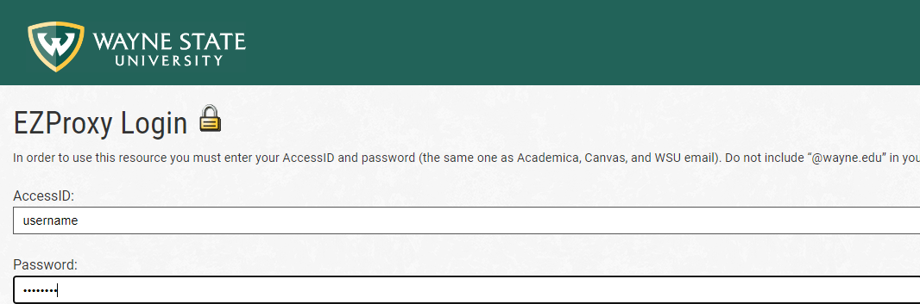

1. Circle the Basic Search bar and put a checkmark on the location of the Advanced Search tool.

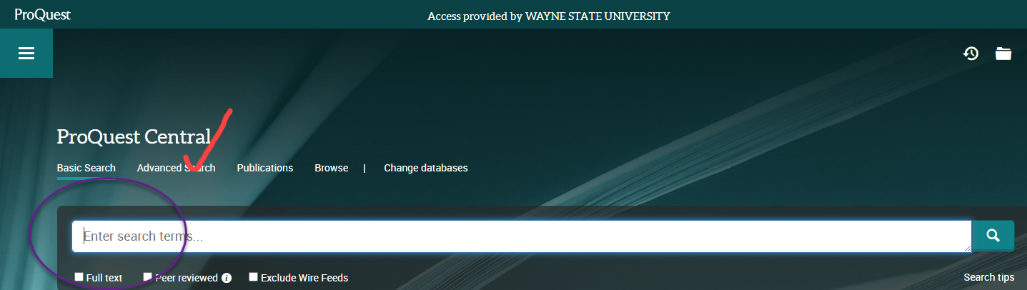

## Answer Key Part 2

1. Match each Boolean operator to the description of what each operator accomplishes in the search.

__b__ AND operator

__c__ OR operator

__a__ NOT operator

Descriptions

1. A limiting operator that will find all sources that have the word “theology” but doesn’t have the word “scholasticism.”
2. A limiting operator that will find all sources that have both the word “theology” and the word “scholasticism.”
3. An expanding operator that will find all sources that have the word “theology” and all sources that have the word “scholasticism.”
4. Match each Advanced Search function to the description of what each feature provides.

__b__ Peer reviewed

__d__ Full text

__a__ Cite

__c__ Email

Descriptions

1. Will use this tool to help format your references during the research process.
2. Using this tool will give you sources that have gone through a quality control process from their peers, to help ensure that the published work is valid, original, and of high quality.
3. Filling out this tool will allow you to send the source to your own personal message inbox.
4. Using this tool will give you sources that you will have complete access to.
5. List the order to use each function located in the Advanced Search tool, as listed below, in the correct steps to conduct the best possible searched and get the best information.

__4__ Cite

__3__ Full text

__2__ Peer reviewed

__5__ Email

__1__ Boolean operator

You have finished the assessment for this instruction. Each question is worth one point, for a total possible 15 points. You must score 15 out of 15 to demonstrate mastery of the terminal objective. If your score was less than 15 points, please review the instruction again and retake the assessment until you achieve that score.

# Reference

Smith, P.L., & Ragan, T.J. (2005). Instruction Design (3rd ed.) Hoboken, NJ: John Wiley & Sons.